Copyright © 2020, Inspironics Corporation, USA
17 July 2020

25 June 2020
25 June 2020
Inspironics LLP – Amenos
Software Design Document (Ver 0.4)
25 June 2020

Revision History

Doc Version | Release Date | Prepared by | Remarks
0.1 | 27 April 2020 | - Hari Prasath | Initial Version
0.2 | 30 April 2020 | - Hari Prasath | Added Kinisi operation and communication packet
0.3 | 23 June 2020 | - Hari Prasath | Updated Kinisi operation
0.4 | 17 July 2020 | - Hari Prasath | Added Descriptions and Updated section 3 ,4

Ref. no.: QM/IIL-Amenos/SDD/July 17

Table of Contents
1. Introduction 6
2. Document Purpose 6
2.1 Product Brief 6
3. System Overview 6
3.1 Hardware Architecture 7
3.2 Major Components 8
3.3 Hardware Brief 8
3.3.1 ESP32WROOM32U Module 8
3.3.2 Internal Flash 8
3.3.3 Dot Matrix LED Display 8
3.3.4 Capacitive Touch Button 9
3.3.5 Temperature Sensor 10
3.3.6 Light Sensor 10
3.3.7 IR Transmitter 10
3.3.8 Relays 11
3.3.9 Buzzer 11
3.3.10 WDT 11
3.3.11 ETRX357HR Zigbee Module for lighting control and dimming 12
3.3.12 IO Expander 12
3.3.13 Debug console 12
4. Software Architecture 13
4.1 Status indication LED 13
4.2 Operating Mode 13
4.2.1 Configuration Mode (Amenos Registration to TIRISI & HUB) 14
4.2.2 Normal Mode 15
4.2.3 OTAP Mode 19
4.3 Communication message flows 20
4.3.1 Tirisi - Amenos BLE communication 20
4.3.2 Amenos BLE Frame Format 21
4.3.3 Communication with Hub 22
4.3.4 Communication with Light using Zigbee 27
4.3.5 Amenos - Kinisi Communication 29
5. Appendix A – Overall software design flow 34
Error! Hyperlink reference not valid.
Error! Hyperlink reference not valid.
Error! Hyperlink reference not valid.
Error! Hyperlink reference not valid.
Error! Hyperlink reference not valid.
Error! Hyperlink reference not valid.
Error! Hyperlink reference not valid.
Error! Hyperlink reference not valid.
Error! Hyperlink reference not valid.
Error! Hyperlink reference not valid.
Error! Hyperlink reference not valid.
Error! Hyperlink reference not valid.
Error! Hyperlink reference not valid.
Error! Hyperlink reference not valid.
Error! Hyperlink reference not valid.
Error! Hyperlink reference not valid.
Error! Hyperlink reference not valid.
Error! Hyperlink reference not valid.
Error! Hyperlink reference not valid.
Error! Hyperlink reference not valid.
Error! Hyperlink reference not valid.
Error! Hyperlink reference not valid.
Error! Hyperlink reference not valid.
Error! Hyperlink reference not valid.
Error! Hyperlink reference not valid.
Error! Hyperlink reference not valid.
Error! Hyperlink reference not valid.
Error! Hyperlink reference not valid.
Error! Hyperlink reference not valid.
Error! Hyperlink reference not valid.
Error! Hyperlink reference not valid.
Error! Hyperlink reference not valid.
Error! Hyperlink reference not valid.

Acronyms and Abbreviations
AC | Air Conditioner
ACK | Positive Acknowledgement
AP | Access Point
APP | Android Application
BLE  EPID | Bluetooth Low Energy  Extended PAN ID
ID | Identifier
UUID  NTP | Universally Unique Identifier  Network Time Protocol
NVM | Non-Volatile memory
NACK | Negative Acknowledgement
PAN | Personal Area Network
SOC | System on Chip
TCP  WDT | Transmission Control Protocol  Watch Dog Timer
ZCD | Zigbee Coordinator Device
ZED | Zigbee End Device
ZR | Zigbee Router

Introduction
INSPIRONICS Corporations intends to develop a new product hereafter called Amenos which is an IOT connected device used for controlling AC and lighting devices in rooms.
QMAX Systems India Pvt. Ltd. is an Electronics Engineering and R&D Services Company which will design, develop, test, and deliver the prototypes matching the requirements of INSPIRONICS Corporations.

Document Purpose
The purpose of this document is to describe the Software design details of the product Amenos being developed by QMAX Systems India Pvt. Ltd. for INSPIRONICS Corporation

Product Brief
The overall product is mainly used for controlling and Room lighting and Air Conditioners which may be of either Legacy type HVAC or Split-AC.
It uses ESP32WROOM32U module which has in-built with Wi-Fi and Bluetooth peripheral for wireless connectivity.
It acts as main controller as well and hence communicates to multiple peripherals through different interfaces.

System Overview
Amenos is one of the sensors, in the CALEIDO product line. Amenos main functionality is to control room temperature through HVAC or Air conditioner and room lighting through Zigbee devices(light). As shown in Figure 1
Amenos uses Wi-Fi and BLE for communication. Wi-Fi is used for communication to the Hub in the vicinity. Hub communicates to the Hotel Wi-Fi Access Point which then communicates to the cloud server. Amenos implements TCP for communication to the Hub over Wi-Fi.
It adds provision for connecting to mobile ILL App (TIRISI) through Bluetooth. Mobile App is mainly used for provisioning the Wi-Fi network through Bluetooth communication.
Beside this, it also has provision for collecting proximity data from another IIL product called Kinisi which is an Infrared Proximity Detector. Kinisi senses any movement in proximity and transmits the data via Bluetooth Beacon Technology. The transmitted proximity data gets scanned by the nearby Amenos and it passes the information to the Hub in the vicinity for further action to be taken.

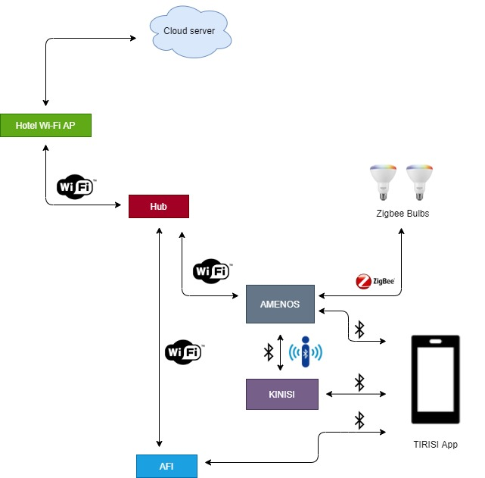
Figure 1 System Overview Block Diagram

Hardware Architecture
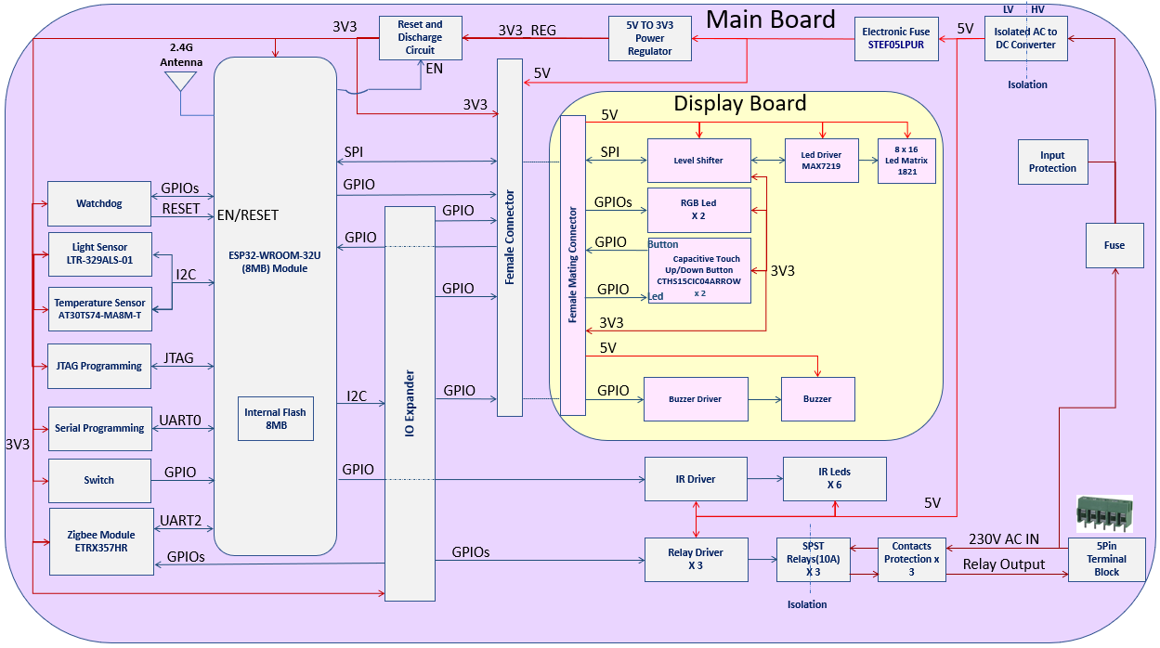
This section discusses about the peripherals and interfaces used in the design. ESP32WROOM32U is equipped with various interfaces like SPI, I2C, ADC, UART etc. which are being used here in the design as shown in Figure 2
Figure 2 Hardware Block Diagram

Major Components
- ESP32WROOM32U (8MB) Module with 8MB internal flash
- ETRX357HR Zigbee Module for lighting control and dimming
- Powered through UL-Certified Isolated Mains Power Supply
- 8 x 16 Dot Matrix LED Display for Temperature Display
- Up & Down Capacitive Touch Button for Temperature Control
- Digital Temperature Sensor
- Ambient Digital Light Sensor
- IR Transmitter for Split-AC Control
- 3-Relays for HVAC Control
- Buzzer
- 2-RGB Leds
- Watch Dog Timer
- Debug console

Hardware Brief

ESP32WROOM32U Module
ESP32 module is equipped with multiple Wireless architectures like single Band Wi-Fi, Bluetooth, Connectivity.
It also has multiple interfaces like SPI, I2C, UART, ADC, multiple GPIOs etc. to list few. It acts as the main control unit.
It interfaces multiple sensors through I2C interface, zigbee module through Uart interface and Dot Matrix Display through SPI interface

Internal Flash
ESP32 is equipped with 8MB internal flash for its application storage.
8MB flash is used in design which is enough memory for future application update as well as OTAP.

Dot Matrix LED Display
8x16 Dot matrix display (white colour) is mainly used to display the set room temperature in either centigrade or Fahrenheit as per user requirement. It can display alphanumeric data on it. Brightness level can be controlled up to 16 steps in software.
Matrix Display requires driver to display data. MAX7219 display driver is used for this purpose. It is Interfaced to MCU through SPI interface.

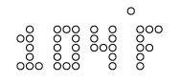

Capacitive Touch Button
As per requirement, system uses 2 Capacitive Touch Buttons which are used for setting AC temperature. CTHS15CIC04 capacitive touch button has been used for this purpose. Overlay will be placed on top of it to indicate the Up/Down Indications. It embeds light in it which glows when Touch Button is pressed.
Based on the Up/Down button is pressed, Amenos will set the required temperature in Air Conditioner. It will notify to the Hub about the set temperature by user.
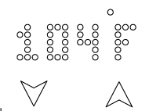

Up Button Pressed
When user presses Up button, set temperature is incremented by 1 degree. Temperature can be set up to 28 degree Celsius. Trying to set temperature beyond 26 degree Celsius is ignored.

Down Button Pressed
When user presses Down button, set temperature is decremented by 1 degree. Temperature can be set to minimum 16 degree Celsius. Trying to set temperature below 16 degree Celsius is ignored.
In both cases i.e. either Up/Down button pressed, Amenos will send command to Split AC to set the desired temperature or in case of HVAC, it will switch on relay to set the desired temperature.
Amenos will also send corresponding set temperature to Hub as an acknowledgement.

Capacitive Button Lock
To restrict guests from setting desired temperature especially as per government restriction of Covid19 measures, Amenos stops sensing these buttons press. This lock is enabled by packets from hub which can be disabled also by packets from hub.

Temperature Sensor
Temperature sensor is used in design to read the Ambient Room Temperature. Temperature read from sensor is sent to the hub through sensor and health packet. Based on sensed temperature, hub can send command to increase/decrease room cooling. Temperature measurement is available in both Centigrade and Fahrenheit.

It can measure both positive and negative temperature. Same will be sent to Hub also in health packet.

Light Sensor
Light Sensor is used for sensing Ambient light which interfaces to the MCU through I2C interface. Based on light intensity, brightness of Dot matrix display can be controlled up to 16 steps.
It is mainly used to detect ambient light and accordingly adjust the brightness of the Dot matrix display to give pleased view.
It may also be used for controlling room lighting in future.

IR Transmitter
For Split AC Temperature Control, IR transmitters have been used.
These are driven using transistor-based driver.
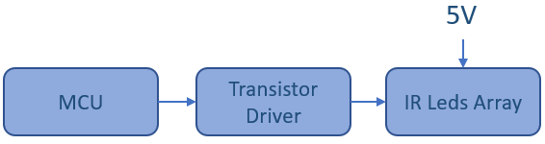

All the IR leds are driven from common gpio in MCU.
Multiple of transmitters on design ensures data to be transmitter in different angles and directions.
Proper IR filters have been used in design for filtering Spurious emissions.

For more details on Split AC control, refer section 4.3.3.2.2

Relays
3 Relays have been used in design to control Fan and Cooling of HVAC system. Each relay is rated at 250V@10A.
Individual transistor driver (Darlington pair) has been used for each relay drive.
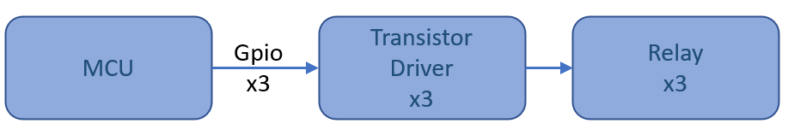

Relays output are terminated to Terminal Block.
Each of the 3 Relay contacts are protected using capacitor.
Depending on the required AC temperature in HVAC system, relays can be turned on and off in software.
For more details on relay operation, refer section 4.3.3.2.1

Buzzer
Buzzer has been added to the design for Alarm as well as capacitive button press confirmation.
Transistor driver is used for driving the buzzer.
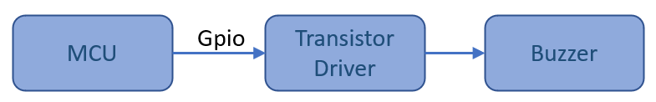

Use Cases
- Buzzer alarm can be used for multiple case like when capacitive up/down button is pressed, it will raise single beep to acknowledge that switch has been pressed
- It can also be used in case of over-temperature. If over temperature occurs, it will raise alarm with 1sec ON/OFF cycle for 10 beeps.

WDT
Watchdog timer has been added to reset the MCU in case of malfunctioning or MCU getting non-responsive for more than specified amount of time (set in hardware).
Watchdog timing is set in hardware through single resistor. Watchdog reset is connected to MCU reset pin which means it will reset the MCU once watchdog timer expires.
To avoid resetting the MCU, watchdog must be cleared in specified window through MCU GPIO at regular interval.

ETRX357HR Zigbee Module for lighting control and dimming
Amenos can control Zigbee Certified lights. It can do ON/OFF control as well as Colour control. For this purpose, Amenos interfaces FCC Certified Zigbee module which are based on readymade AT commands. As these are AT commands based, complex firmware need not be developed for this.
For more details on lighting control refer section 4.3.4

IO Expander
As multiple peripherals are required for the application design and there are limited GPIOs available on ESP32 module and multiple pins are not accessible for user use, IO expander has been used in the design for controlling multiple peripherals.
There are totally 16 ports available which can be configured either as input or output.
IO expander controls Zigbee module boot and reset pins, RGB led, Capacitive touch button led control, Relays, and senses temperature alert.
IO Expander is interfaced to ESP32 MCU through I2C interface.
Expander gpios can be configured both as input and output. It can generate interrupt in case gpio is configured as input and interrupt is enabled when there is change of state. MCU gets notified with interrupt after which MCU can read the change in state.

Debug console
For debugging purpose, Uart connections have been terminated. User can get debug logs for functional test as well as for debugging purpose.

Software Architecture
Following section describes the application architecture.

Status indication LED
There are 2 RGB Led indications present on board. Led color denotes different modes as described in Table 1
# | Operating Mode | Phase | LED1 | LED2
1 | Configuration Mode | Until boot | Blink Red | Blink Red
 |  | Device ready | Blink Green | Blink Green
 |  | Connected to TIRISI App | Constant Blue | Constant Blue
 |  | NACK to TIRISI | Blink Green
2 | Normal Mode | All well after boot | Green
 |  | Error (Over temperature) | Red
 |  | Relay ON or Light ON | Blue
 |  | Contact lost with Kinisi / Light |  | Constant Blue
 |  | Connection with Hub |  | Green
 |  | Connection Lost with Hub |  | Red
Table 1.LED Indication

Operating Mode
Amenos operates basically in either of 3 modes namely
- Configuration Mode
- Normal Mode
- OTAP Mode
Operating mode Overview
When an Amenos is factory new (Wi-Fi parameters not configured), it operates by default in Configuration Mode. In this mode, Bluetooth advertisement starts, and user can use TIRISI mobile app to configure the device credentials and generate Wi-Fi network parameters like SSID and Passkey from it.
After Wi-Fi parameters are generated, Amenos tries to connect to Hub successfully, it switches to Normal Mode of operation. Wi-Fi operates in Station mode. In this mode, Amenos sends health packets at regular interval, waits for commands from hub for AC control, lighting control etc.
In case of new firmware is available for upgrade, it operates in OTAP Mode.
Irrespective of operating mode, ESP module will send pulse to WDT within the window period to prevent ESP32 from getting reseted. If ESP does not give signal to watchdog due to hanging or not responding due to any malfunctions, it resets the ESP module.
If over temperature occurs, buzzer will beep for 10 sec with 1 sec ON/OFF pulse.

Configuration Mode (Amenos Registration to TIRISI & HUB)
- A factory new Amenos has QR code pasted on it which holds the product information. IIL App TIRISI scans QR code and gets the product information.
- By default, a factory new Amenos operates in Configuration Mode. Amenos Wi-Fi operates in station mode. When configured, Amenos can connect to the IIL HUB (acting as Access Point) in the vicinity. To connect to HUB, HUB Wi-Fi parameters like SSID, password need to be configured in Amenos.

Authentication and Connecting to TIRISI App
(for BLE packets, refer 4.3.2)
- To get the device credentials, Amenos enables Bluetooth advertisement with name ‘CaleidoXenia’ so that IIL mobile app TIRISI can connect to it. Led Indication follows as mentioned in Table 1
- When TIRISI App connects to Amenos, TIRISI sends Authentication packet to Amenos. If received password matches with pre-defined password in Amenos, it will send ACK to TIRISI and continue receiving and process the received configuration parameters else it sends NACK.

Device Registration
- After Amenos sends ACK for Authentication packet ,TIRISI sends Device Registration Data BLE packets which will give device registration details like Property Org ID, Facility Id, Ameniety Id, AC type and model used etc that can be used for all the communications to the HUB.
- Amenos generates Wifi SSID and Passkey from the received room number using the pre-defined algorithm.
Algorithm for SSID & Passkey Generation
- It extracts amenity id/room number which is of 6 bytes and use this as HUB’s SSID. Password is generated from same room number and org id, first character and last characters are replaced by "#" and pad org id and amenity id/room number in between them. For example, in terms of simple numeric if room number and org id is stored or supplied as '001001' and ‘100’ respectively, then password could be '#100001001#' and it will be stored in internal flash.

- All the device registration details, and network parameters are stored in internal flash for further processing. While POR, all the parameters are read from NV RAM and used for further processing.

Hub Connection & Acknowledgement to TIRISI
- After Amenos gets Access Point’s (Hub in this case) SSID, password it tries to connect to the IIL HUB in the vicinity. While connection is in progress it will send Wi-Fi connection in progress (0xA1) ACK to App.
- If successfully connected, it will send Wi-Fi successfully connected acknowledgement(0xAA) to App then open a TCP socket and as shown in Figure 11 communication will start in between Amenos and Hub.
Error Handling
- In case, connection to HUB fails for 3 successive trial counts, it sends Wi-Fi connection failure acknowledgement(0xD2) to TIRISI.
- If length mismatch occurs in any of received packets, it sends configuration not written acknowledgement(0xD1)

Amenos Registration to Hub
- After Amenos establish successful connection with HUB, first it will send device registration packet to Hub and waits for acknowledgement from Hub.
- Device will be considered as configured only when it receives device registration acknowledgement as success.
- If it receives device registration acknowledgement as success, it will change mode to Normal Mode and save its mode in internal flash.
- Here after at every POR, it will operate in Normal mode until it receives decommission command from HUB.
Error handling
If it receives device registration as failure or it doesn’t receives any acknowledgement from HUB within 1 minute Amenos will again start operating in Configuration Mode.

Normal Mode
- When Amenos gets successfully connected to HUB, it operates in this mode. It sends device health status (room temperature in degree Celsius)at interval of 1 sec and sensor data (Sender uid, packet type, room temperature, set ac temperature, light intensity, light control, relay on count) at interval of 1 min to Hub.
- It gets Real time Clock using NTP. This timing is used for day and night mode settings. Refer Day and Night Mode settings for more details.
- Led indication follows as per Table 1.
- In this mode, Amenos receives command for controlling AC and Light. It displays the set AC temperature on Led matrix and brightness of Dot Matrix is controlled based on light sensor data and sense capacitive button press for AC temperature control.
- It also waits for OTAP update. In case new firmware is available, it updates it.
- At any time, sensor will receive any of packets from Hub as described in Table 2 and execute process as mentioned.

# | Received Packets | Process done by sensor
1 | Maintenance packet | Turn ON – Be ready for communication to the other server. Command to follow with IP address of server to which packet needs to be sent.
 |  | Turn OFF – Re-establish Communicate to Hub
2 | Shut down packet | Sensors with same amenity id will enter deep sleep mode and stop sending heartbeat to Hub
3 | Mobile IP packet | Extract the IP and send health and sensor data to this IP address. When received, Amenos sends now all the packets to the server with given IP address which was being sent to hub earlier
4 | Decommission packet | Forget network parameters and go back to configuration mode. After this, Amenos acts as factory new device.
5 | Device registration request packet | When hub reboots, Hub requests for device registration packet. Hub sends registration packet again but for this there is no any acknowledgement sent back.
6 | Firmware update packet | Hub gets ready for OTAP and sends OTAP acknowledgement.
7 | Device registration acknowledgement packet | Extract the acknowledgement status field. Then if the field is “1” operate in Normal Mode else operate in Configuration Mode.
8 | Activate Light pairing mode packet | Allow permit joint for light to join the Amenos Zigbee network and assign zone for it.
9 | Split AC control packet | Control Split AC as described in Table 4
10 | HVAC control packet | Control HVAC as described in Table 3
11 | Individual Light control packet | Control individual light ON/OFF, Color etc. based on received packet as described in Figure 12.
12 | Zone light control packet | Control group of lights in the zone based on received packet as described in Figure 12. Lights belonging to the same zone are controlled together like ON/OFF & Color etc.
13 | Over temperature wake after packet | Check whether temperature is in desired set range. If so, operate in Normal Mode else get into sleep mode and wake after some time(10sec) and check whether temperature is in desired range. If yes, continue operation in normal mode i.e. send health and sensor packets else go to sleep again for 10sec.cycle continues.
14 | Lock capacitive touch switch | When enabled, do not consider touch button press for AC temperature setting especially as Covid19 measure. When lock is enabled, temperature setting through capacitive button press is disabled. It can be enabled again when Amenos receives command from Hub.
15 | Force set AC temperature packet | - Extract “status” field. If it is “1”, Set the AC temperature as received and Amenos will not consider touch button press for setting AC temperature. This is done specially as Covid19 measures  - If “status” field is “0”, Disable this setting and user can be able to change the temperature using touch button or via Porta App.
16 | Amenity sleep mode packet | - Turn OFF all lights  - Set AC in night mode setting
Table 2 Operation for received packet

Zigbee Smart bulbs
- Amenos also facilitates connecting to certified Zigbee lightings. Zigbee lights act as Zigbee End Device (ZED). Before lights can be controlled from Amenos, it needs to be registered. For this, HUB will send Activate Light pairing mode packet which include zone, EPID (64-bit) details to Amenos, then Amenos enables network for certain duration after which lights can connect to it.
- After Light joins the network, Amenos search whether the ZID/EPID is matching with received EPID. If so, it sends Light registration packet to HUB else it does not send respective light registration packet
- If successfully registered, Zigbee light can be controlled by Amenos based on the command received from HUB. We can control light’s ON/Off, color, contrast.
- If NACK is received, Amenos disconnects the Light device that connected to Zigbee network.
(for more refer section 4.3.4 )
- At every 5 minutes once check whether ZED is alive in network or not.
- If light is alive, it will send light health status (light mac id also called as epid) to HUB else, it will not send this packet

Zigbee Smart Bulb Zones
- Amenos controls smart bulbs fixed in different zones through Zigbee.
- Each room where Amenos is going to be placed is divided into minimum of three zones.
- The Three zones are identified as:
  - Night Lamps (Zone 1)
  - Living Area (Zone 2)
  - Corridor (Zone 3)
- In case of amenities other than the rooms, Defaults will be “OFF” and can be turned ON manually
- Amenos control lights belonging to the same zone together.

Default Smart Bulb Behavior
Field of use and Parameters | Behavior
Night Lamp Zone | OFF
Living Area | ON
Corridor Area | ON
Brightness | 50%
Color | Warm Fluorescent (255, 244, 229), configurable
Temperature | 3500K

AC control operation
- When Amenos gets power, it will automatically turn ON AC with default mode as “Auto”, then send Power ON AC setting packet to Hub
- If sensor receives AC control packet from hub then action will be performed, as described in section 4.3.3.2
- AC temperature can be set by capacitive touch button or command from HUB (sent from Porta App)
- At any time if user presses the capacitive Up/Down button for setting AC temperature, Amenos send sensor data to HUB instantly.
- By Default, Amenos sets AC according as Day/Night mode based on real time clock which means AC temperature by default will be set to the default Day/Night temperature however if required, guests can set the temperature as and when required.

(For HUB communication packets refer Communication with Hub )

Kinisi-Amenos communication
- Kinisi acts as slave of Amenos. It gives notification is any movement is detected in proximity.
- To communicate, Kinisi needs to be first registered to Amenos.
- For detailed description refer section 4.3.5

Wake After in case of Over temperature
- Amenos monitors temperature on regular basis and transmit it to hub.
- Hub monitors received temperature from sensor and Upon Over Temperature, Hub will send ‘Wake-After’ command and send over temperature alert to the Ikanos
- Amenos implements protocol handling such that upon receipt of the command “Wake-After”, it goes into deep sleep mode and wakes after a default time period of “10 Seconds”. This is build-configuration parameter.
- After 10 Seconds, Amenos will wake up and work in normal mode.
- Hub shall not declare “Man-Down” during the 10 Second period. The “OverTemp” Alert will not be reset until the affected sensor temp readings go below the thresholds
- Over temperature “Set” will happen at 50 Deg C and “Reset” will happen at 45 Deg C.
- Between Set and Reset, it is highly possible that Amenos will go through cycles of wake-up and going back to deep-sleep mode.

Preventive Maintenance
- To track and keep record of maintenance, Amenos always monitors relays and lights operations.
- For HVAC, whenever relay is turned ON, it increments count by 1. As there are 3 relays, it maintains counts individually and reports the same to hub in sensor packet. Hub can take preventive maintenance accordingly like if any of relay is turned ON for more than the specified limit, it will generate alert accordingly.
- Similarly, for all the connected lights, it keeps record of how long individual bulb has been switched ON and stores in memory. It also passes the same information in sensor packet before sending to hub. If certain bulb crosses the total ON time beyond the limit, it must be replaced and hence alarm should be raised for it.

OTAP Mode
- If new firmware is available, Hub initiate OTAP process by sending Amenos OTAP packet to Amenos, then Amenos operates in OTAP mode.
- It will update the new firmware without changing the configuration parameters and roll backs to Normal Mode operations as described in 4.2.2
- If new firmware is updated successfully it will send OTAP ACK packet to Hub and operates with respect to new firmware
- If new firmware is not updated successfully it will OTAP ACK packet to Hub and remain operating as per its old firmware

(For more details refer Appendix A – Overall software design flow diagram)

Communication message flows
This section discusses about wireless communication with Amenos

Tirisi - Amenos BLE communication
This section discusses about BLE frame format and how Amenos and android BLE App communicates.
A factory new Amenos advertises with name ‘CaleidoXenia’ at POR. TIRISI app can connect and configure device parameters.
Figure 3 illustrates the how Amenos communicates with android App.
- First App will send password packet and waits for ACK from Amenos.
- If ACK is received (password matches), App sends Device configuration parameters and waits for ACK from sensor.
- If NACK, App will not send Device configuration parameters
- Using those device configuration parameters, Amenos will connect to AP (Hub) to get internet access. Configuration parameters and its allocated byte are shown in section 4.3.2

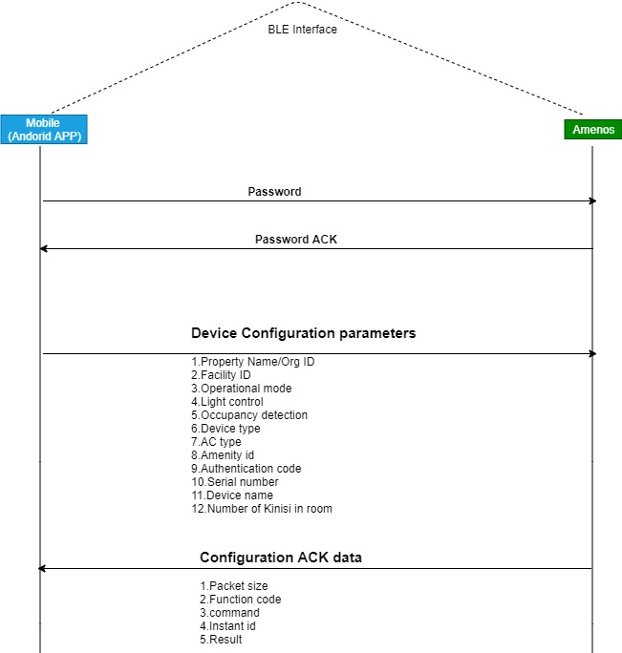
Figure 3 Android App and Amenos communication

Amenos BLE Frame Format
This section discusses about frame format for Amenos with IIL Mobile App (TIRISI) over BLE interface.

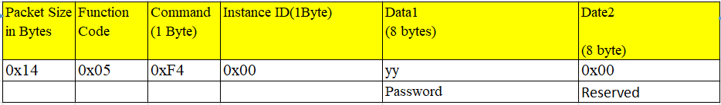
Authentication packet

Figure 4 BLE - Password Packet

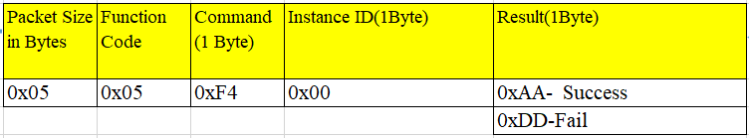

Figure 5 BLE - Password ACK Packet

Device Registration Data BLE packets
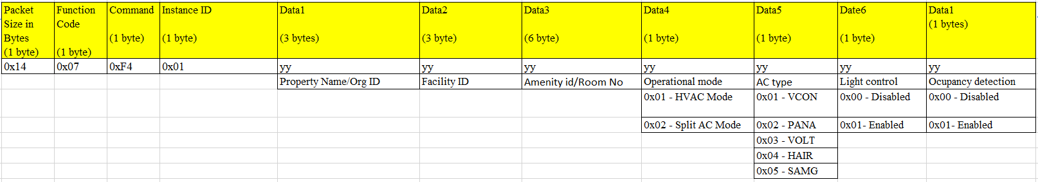
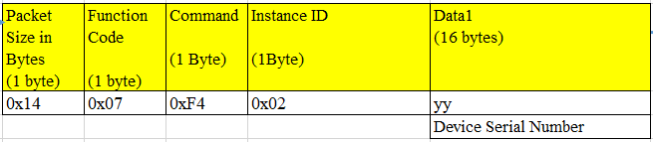

Figure 6 BLE - Room Credentials Packet
Figure 7 BLE - Device Serial Number Packet

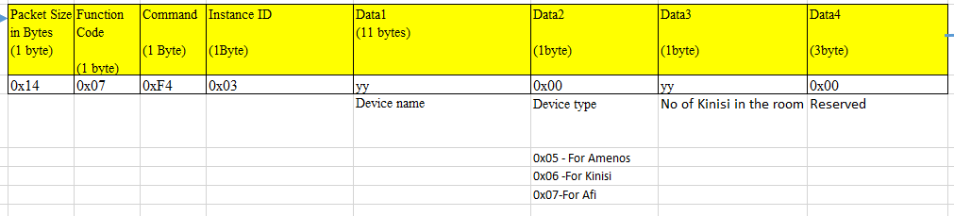
Figure 8 BLE - Device Name Packet
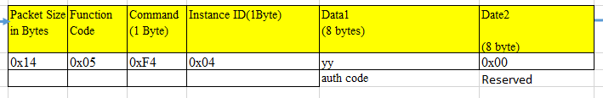
Figure 9 BLE Auth code
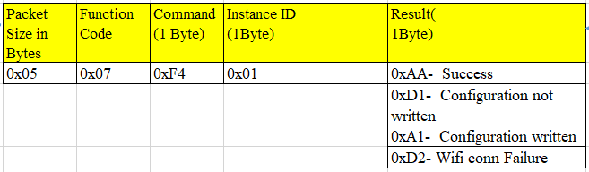
Figure 10 Device Configuration ACK Packets

Communication with Hub
This section discusses about how Amenos communicate with Hub. Figure 11 illustrate the communication between Hub and Amenos.
After Tirisi sends device parameters, Amenos generates Hub SSID and Passkey from it. It then tries to connect to Hub and sends registration parameters.
Once registered, Amenos sends health status and sensor data periodically.
It can also register its slaves which are Kinisi (for movement detection) and zigbee lights for lighting purposes.
It communicates to Hub frame format described next.

Data Encryption using HMAC
All packets are having “hmac” field which is used for authentication. It is calculated using SHA256 algorithm.

Hub Communication Packet
In Qmax Systems - IIL Amenos Hub Communication Packet Definition Document V0-7 16-July-2020.doc.Hub communication packets are defined.
Please refer the document for more details.
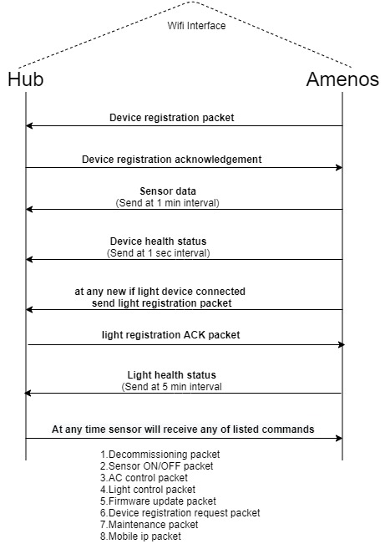

Figure 11 AMENOS communications with Hub

AC Control
One of key task Amenos does is it controls Room Air Conditioners.
Amenos can control both AC types
- Split AC (through IR Control)
- HVAC
Before Amenos can control either of Air Conditioners types, a factory new Amenos must be configured if it needs to control Split AC or HVAC. This configuration is done at the time of device registration of Amenos using TIRISI app.
From received BLE frame, the field “Operational mode” decides whether Amenos needs to control Split AC or HVAC.

AC temperature can be controlled through two options
- Capacitive Up/Down Button Press
- Controlled from Hub (Commands from Porta App)
- Capacitive Up/Down buttons can be used to set the desired temperature (16-28 degree).
Once temperature is set, Amenos sends command to control the Split AC through IR and in case of HVAC, it controls corresponding relays to bring to desired temperature
- Instead of using AC remote user can use IIL PORTA Mobile App to control the AC. All AC operation like mode changing, temperature changing, turn ON/OFF can be done using PORTA.
- When user configures all requirements using PORTA, PORTA will send that configured data to IKANOS server. From server Hub will get information and pass to Amenos via Wi-Fi interface. Amenos receives those data and control the AC using IR transmitter.

Force Set AC temperature
In case of Pandemic situations, there may be case when AC temperature is set to the fixed temperature. For this, Amenos implement option not to change the AC temperature both split and HVAC type manually using capacitive Up/Down button press and through hub (through Porta App). In such case, AC temperature will be set to fixed temperature and maintained in case of HVAC by Amenos.

HVAC mode Operation
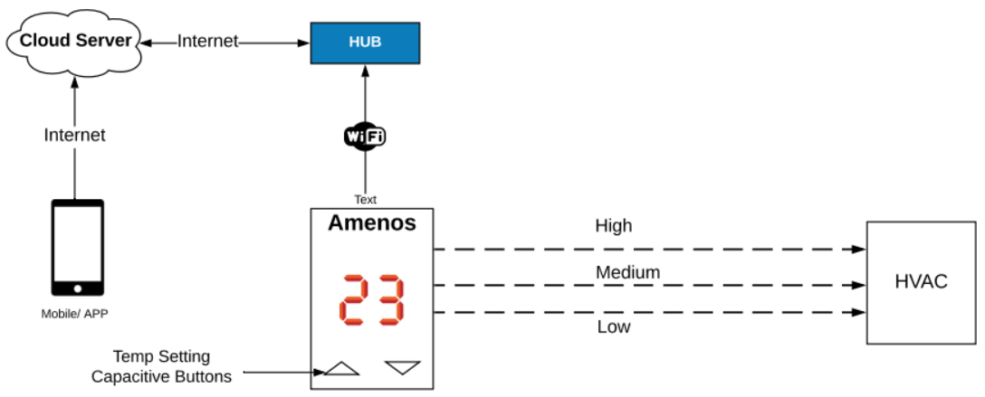
Figure 12 HVAC - operation

If HVAC mode is selected, by default HVAC will be set to Auto mode but still user will be able to control cooling manually. Refer Table 3 for more details.
Control | Command | Action
Mode | Cool | - Turn on high speed relay and keep as it is until the set temperature is reached. After that, the relay will be switched off and turned ON again if the Temperature is greater than set temp.  - Some hysteresis will be added to avoid frequent ON/OFF of relays when temperature rises above the set temperature.
 | Auto  (Default) | - Turn on power, If Ambient Room Temp > 30 Deg C, Turn ON High speed Blower Relay  - If Ambient Temp in range 25 – 30 Deg C, Turn ON Medium speed Blower Relay  - If Ambient Temp <25 Deg C, Turn ON Low speed Blower Relay  - At desired set temperature blower’s Relay will cutoff  - Some hysteresis will be added to avoid frequent ON/OFF relays when temperature rises above the set temperature.
Temperature Setting 16 – 28 º C
Table 3. HVAC mode operation

Split AC Mode
If Split AC mode is selected, standard Split AC settings will be accepted as described in Table 4
# | Control | Settings Accepted | Action
1 | Power | On | Send IR frame to turn ON AC
 |  | Off | Send IR frame to turn OFF AC
2 | Mode | Cool | Send IR frame to change AC mode as cool
 |  | Auto | Send IR frame to change AC mode as Auto
 |  | Dry | Send IR frame to change AC mode as Dry
 |  | Fan | Send IR frame to change AC mode as Fan
3 | Temperature | Temperature range (18 -28) º C | Send IR frame to change AC temperature
4 | Time | Day Mode | Set temperature to Day temperature (for e.g. 20ºC.
 |  | Night Mode | Set temperature to Night temperature (for e.g. 28ºC.
Table 4 Split AC Settings

Day and Night Mode
- This is the default mode of operation.
- Day and Night modes are based on real time. Amenos gets this time from Hub through NTP.
- Ikanos sends “timetable” for Day mode and Night mode Start times, End Times, and the AC temperature to be set to hub which is received by Amenos for further processing.
- Based on these configurations, AC temperature is controlled automatically by Amenos.
- However, Amenos will not turn OFF Lights in this mode.

Sleep Mode
- Sleep mode is triggered by Guest using AFI. Accordingly, Hub sends packets to Amenos to enable Sleep mode settings.
- Sleep mode can be activated anytime by guest. Amenos will switch the temperature to “Night Mode” temperature and switch off all the lights.

AC control using IR
This section discusses about how AC is controlled by Amenos using IR transmitter.

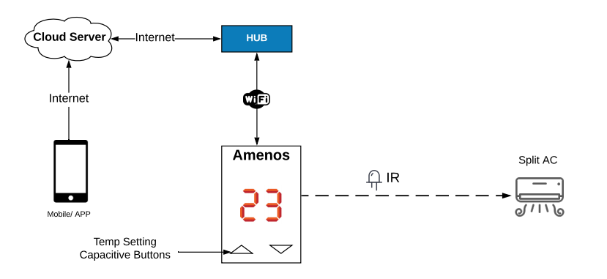
Figure 13 Split AC control using IR

AC is controlled by using open source IR library https://github.com/crankyoldgit/IRremoteESP8266/tree/master/src
Amenos will have support for Split AC from following vendors
- Videocon
- Panasonic
- Voltas
- Haier
- Samsung

Multi-Directional Split AC Control
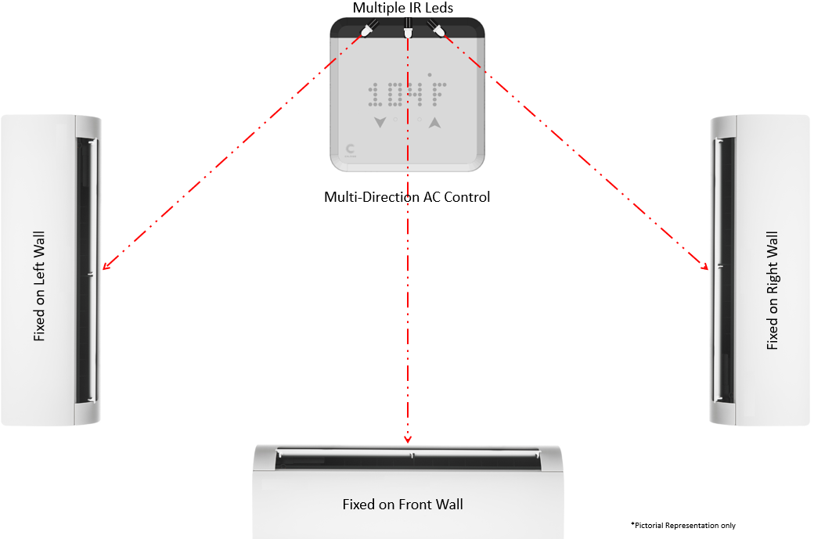
Figure 14 Control AC using IR

Amenos uses arrays if IR transmitter facing multiple angles for longer area coverage. It can control Split AC fixed in different directions i.e. on opposite wall or side walls(left/right). Picture is just pictorial representation (in actual it will control just one AC not multiple, image just showcasing that Amenos can control ACs fixed on walls in different directions) of Amenos controlling Split AC fixed in different directions on wall.

Communication with Light using Zigbee
- Amenos features Zigbee communication for controlling Zigbee certified lights. To communicates Zigbee certified lights, first they need to be configured and registered with IIL HUB and cloud server.
- For this, Amenos enables join for certain duration during which light can join. After join is successful, Amenos gets light information and IEEE address.
- After this, Amenos sends all this information to the HUB which then passes to the cloud server. HUB then sends either ACK or NACK based on if its authentic registration process else it discards the light connected and drops connections.
- In case light wants to connect again, it needs to follow the steps mentioned above.
- In Figure 15, it is described that how Amenos communicate with Zigbee light, light registration process and control light via Amenos from the commands received from Hub.
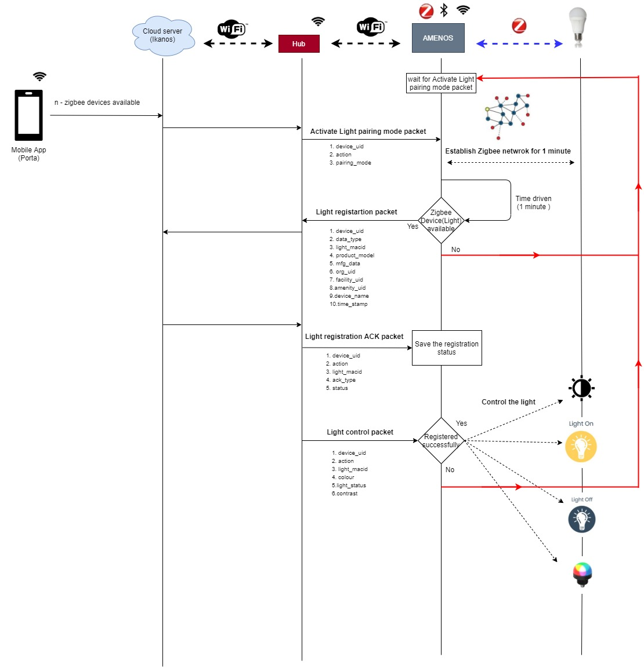
Figure 15 Zigbee device Communication

Amenos - Kinisi Communication
Kinisi acting as slave of Amenos detects movement if any and send it to Amenos.
Amenos to Kinisi are categorized in 2 types
- Amenos with Kinisi
- Amenos without Kinisi
For Amenos with Kinisi type, to communicate with each other, Kinisi needs to be registered first to Amenos.
Amenos knows how many Kinisi will present in room through TIRISI app
(for more refer Figure 8)
Amenos searches for that many numbers of Kinisi for registration
For Amenos without Kinisi, movement sensing option will be disabled.

Amenos-Kinisi connection
- When Kinisi successfully configured with using TIRISI, it changes its advertising name so Amenos can connect to it. Kinisi operates in peripheral mode until it gets registered to HUB via Amenos.
- Once Amenos establish a connection with Kinisi, first it sends Kinisi Authentication packet, then Kinisi send acknowledgement packet.
- If acknowledgement is successful, Amenos receives the registration packets from Kinisi else, it disconnects Kinisi.

Data transfer
- If acknowledgement is success, Amenos will receive Kinisi room credentials, Kinisi device serial number, Kinisi device details packets from Kinisi. While receiving this any of these packets if length mis matches or Command byte mis match or not received 3 packets it will send NACK to Kinisi and disconnect from Kinisi.
- If Amenos- Kinisi connection get disconnected due to any malfunction it will discard the packets and no operation will be performed

Device registration
- If successfully received all device configuration parameters, Amenos check whether it has same room number or not.
- If same room number, Amenos sends Kinisi device registration packet to HUB else, it will discard the received packet and disconnect Kinisi
- After sending device registration packet within 1 minute if HUB doesn’t respond or send device registration status as failure, Amenos send NACK to Kinisi
- If HUB send device registration status as success, Amenos will send ACK and disconnect from Kinisi, then save serial number and device name in flash for sending sensor data and health status of Kinisi to HUB.
- In these cases, Kinisi changes its mode and starts sending movement detection
- If device registration fails Amenos will retry max 3 times. Within this 3 retries if Kinisi is not registered, Amenos will send the unregistered Kinisi device count to HUB. In such case, Kinisi still advertises in peripheral mode and looks for getting registered to Amenos.

Kinisi to Amenos Normal Mode Communication
- In Normal mode, Kinisi uses Beacon advertisement for communicating to Amenos. This communication is uni-directional i.e. Kinisi just advertises packets over the air through BLE Beacon standard.
- Amenos in proximity scans for nearby Kinisi and check whether room number field in the beacon packet matches with Amenos room number.
- If room number matches, Amenos will extract required details and pass it to Hub through Wi-Fi.
- If mac id does not match, Amenos will discard the scanned data

Hub communication
If Kinisi is successfully registered, using scanned beacon data Amenos will send sensor data (sensor uid, battery voltage, occupancy detection) and health status (operating mode, battery level, occupancy detection, battery percentage)to HUB
(for more details refer Figure 16)
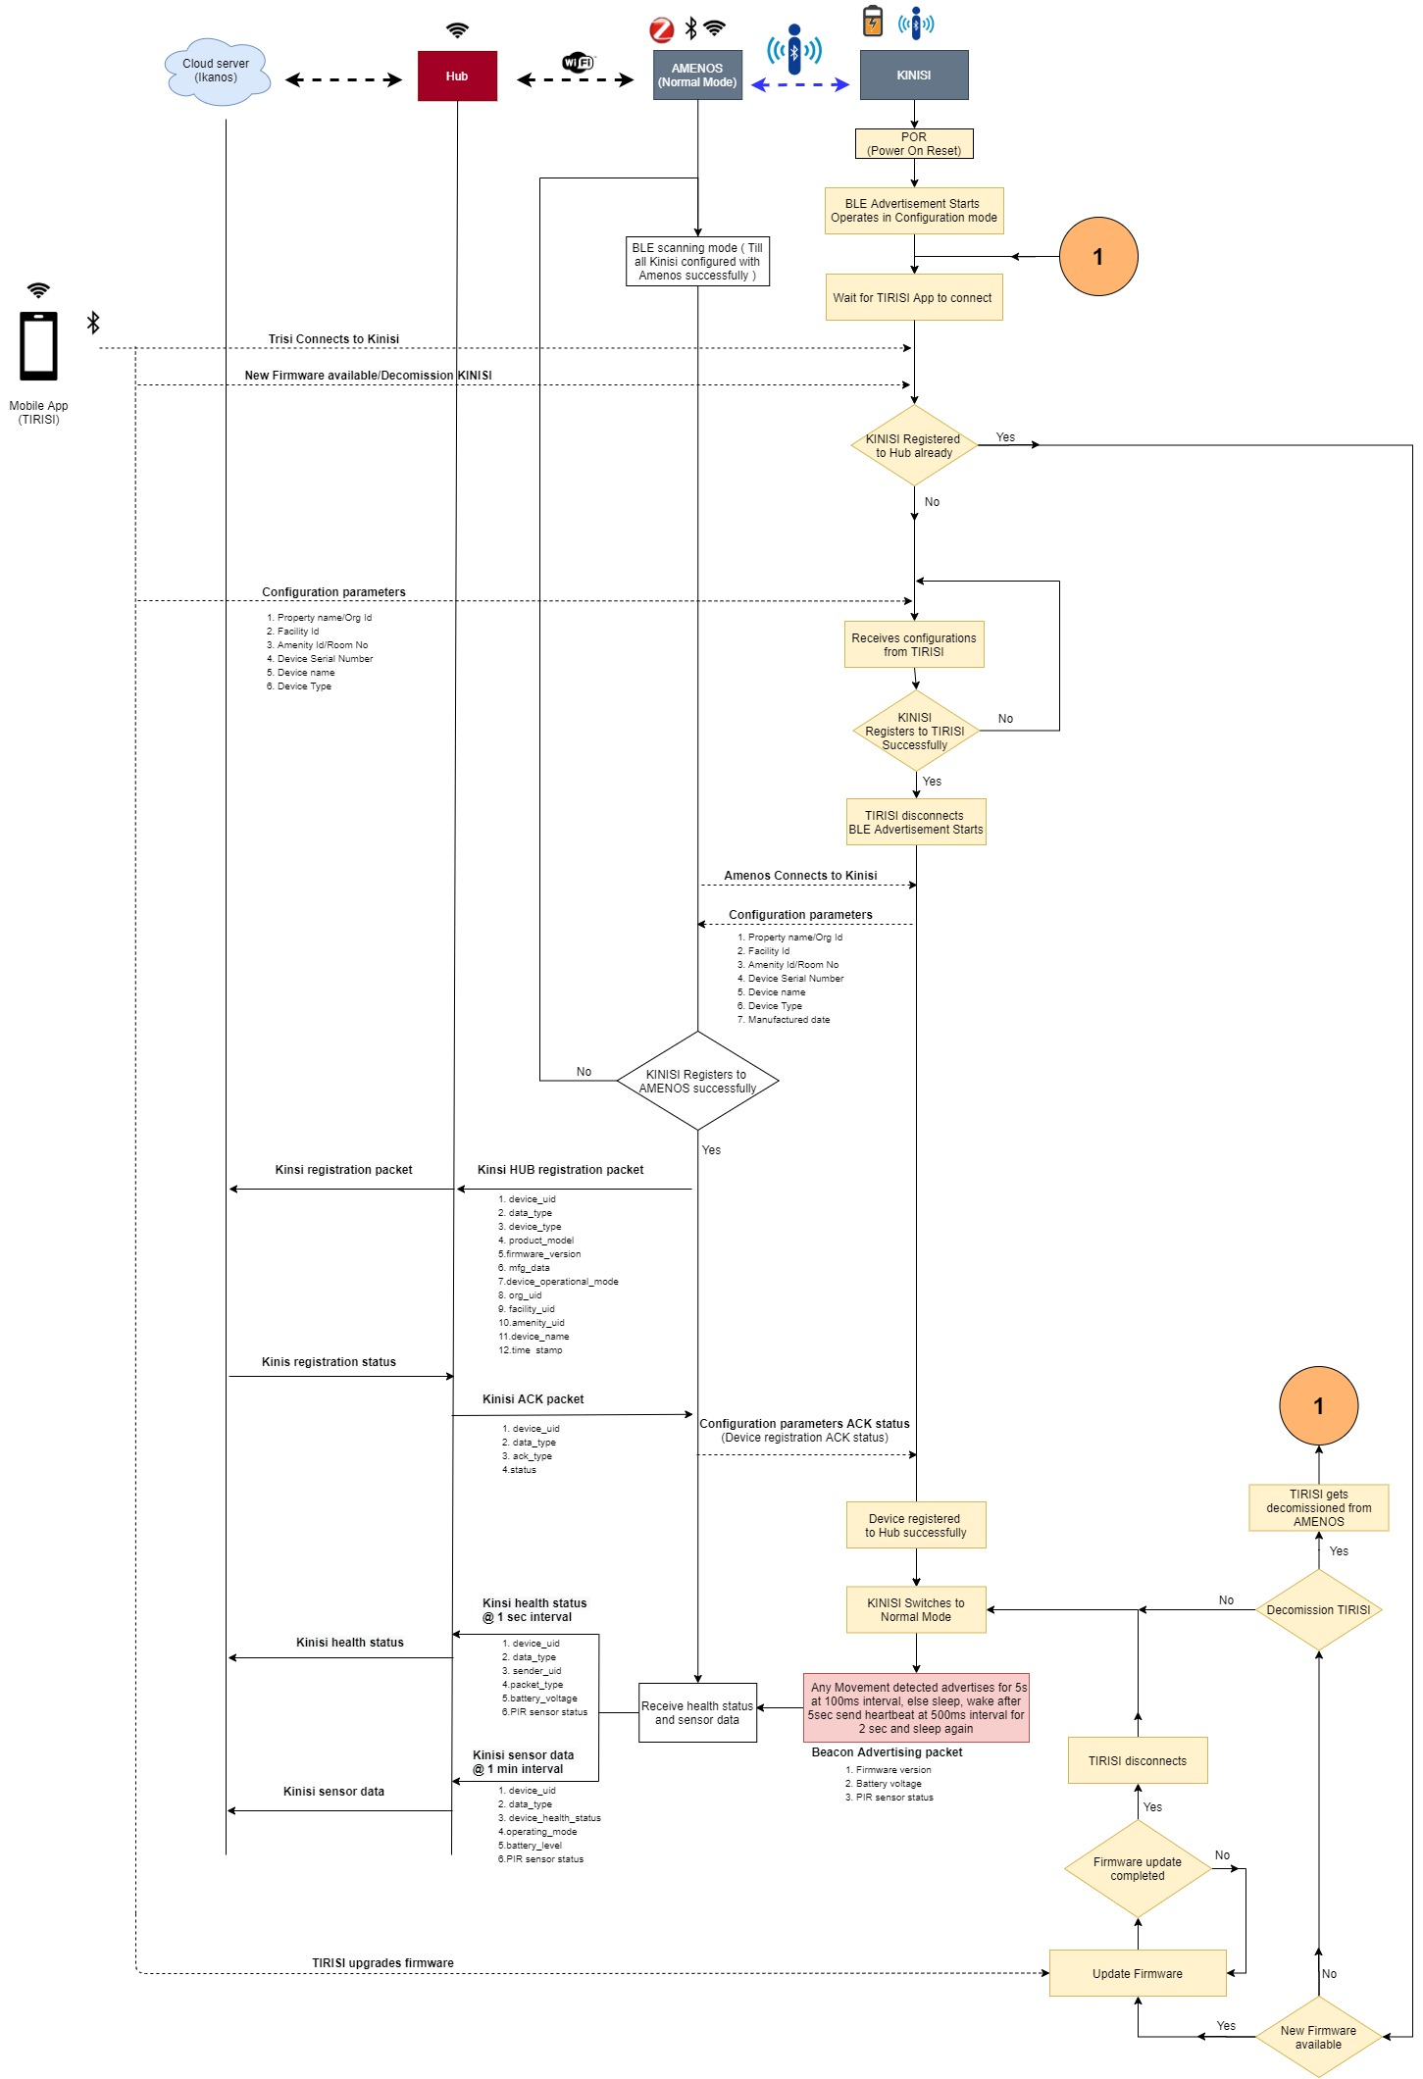
Figure 16 Kinisi-Amenos-Hub message diagram

Kinisi – Amenos BLE Frame Format
This section discusses about Kinisi – Amenos BLE communication packet

Kinisi – Amenos Authentication packet

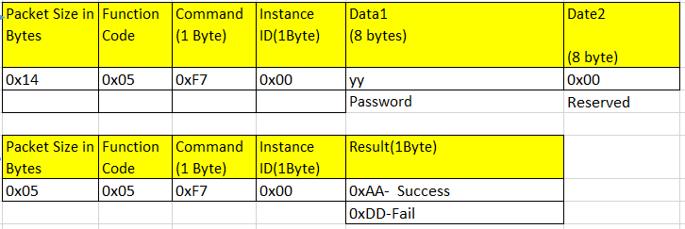

Figure 17 Kinisi Authentication packet

Kinisi – Amenos configuration BLE packet

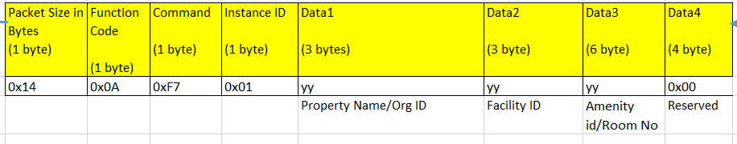

Figure 18 Kinisi room credentials
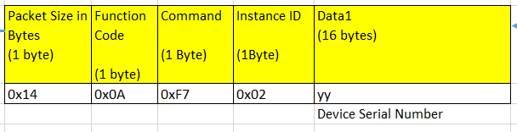
Figure 19 Kinisi device serial number

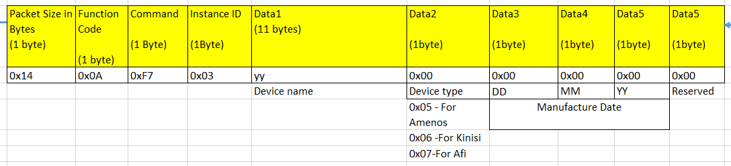
Figure 20 Kinisi device details

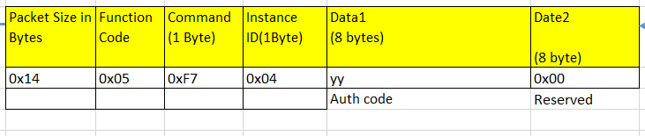
Figure 21 Kinisi Auth code

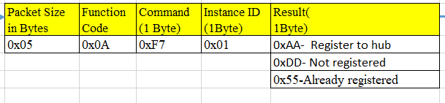
Figure 22 Kinisi device configuration ACK packet

Kinisi – Amenos BLE-Beacon Advertising packet
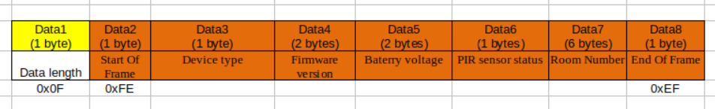
This section discusses about BLE – Beacon advertising packet
Figure 23 Kinisi BLE - Beacon advertising packet

Appendix A – Overall software design flow
Whenever system is powered up (POR), it starts the main Application by initializing the parameters shown in Figure 24. Then the system will operate in any one of the operating mode described section 4.2 and execute operation with respective to operating mode.
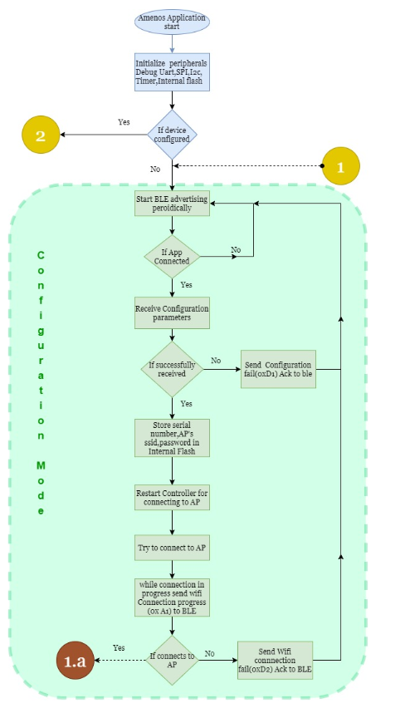
Figure 24 Configuration mode operation

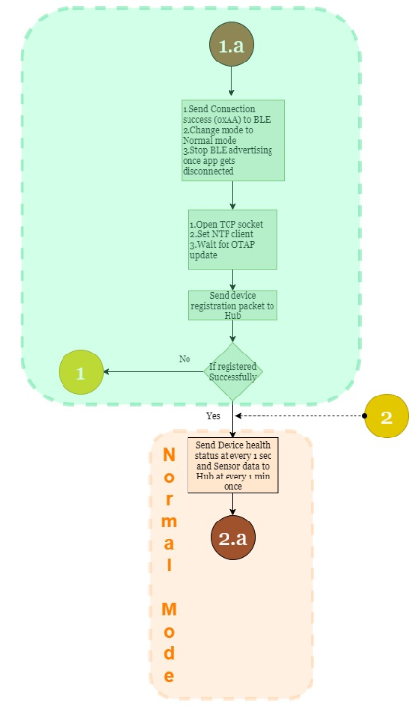
Figure 25 Normal Mode operation

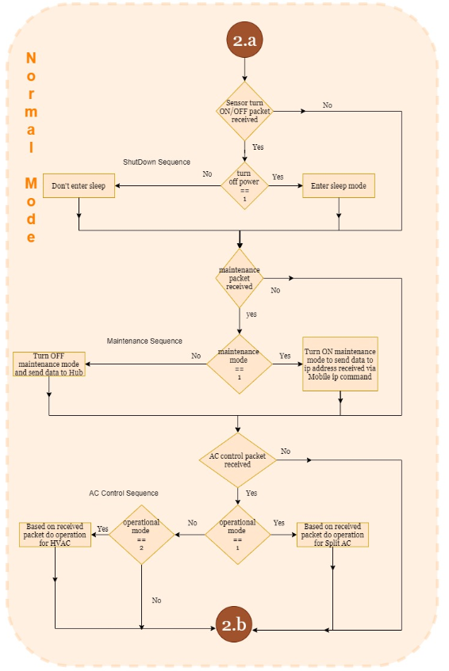
Figure 26 Normal mode operations 2.a

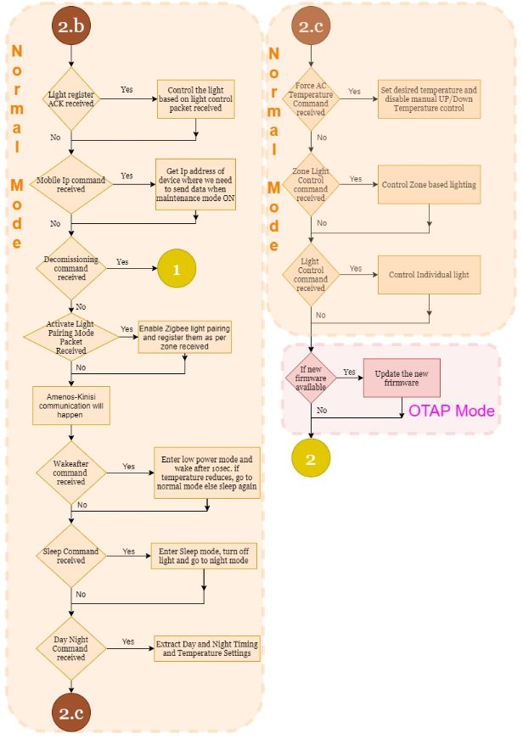
Figure 27 Normal mode operations 2.b and OTAP Mode

--------------------- End of Document -----------------------

